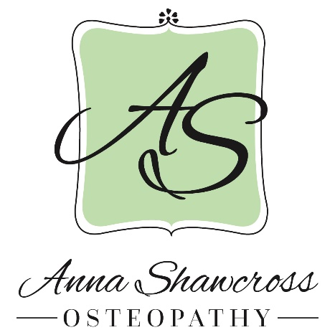
Health and Safety Procedures

1 – call me for appointment. I will conduct a telephone triage for Covid-19 and potential need for a face to face consultation.
Here are the Covid-19 screening questions:
- Have you had close contact with or cared for someone diagnosed with COVID-19 within the last 14 days? YES / NO
- Have you experienced any cold or flu-like symptoms in the last 14 days (to include fever, cough, sore throat, respiratory illness, difficulty breathing, loss of smell or taste)? YES / NO
2 – If we are unable to conduct a face to face consultation then you will be offered a videoconference with diagnosis, lifestyle and exercise available.
All case history questions for new symptoms will be conducted over video conference or the telephone and notes taken. This is a vital part of the consultation and part of the diagnosis process. And it will reduce the time spent face to face.
3 - Important information before arrival.
- Please may I ask that you are recently bathed and wearing reasonably clean clothing for your appointment. I may need to open the window for ventilation for some techniques and therefore please wear loose fitting sports type clothing, vest top and shorts is perfect, in case the room is cold.
- Government guidance stipulates that within 2 meter contact you are advised to wear a face covering. This can be a shawl or mask of the clinical type or a homemade cloth type. Whatever you can find that is comfortable for you.
- I also ask that no other persons accompany you unless with prior approval and that you only bring what is absolutely needed for your appointment.
- Please arrive on time to avoid cross over with other patients.
4 – Upon arrival at the Empire Hall please wait outside or in your car at the recommended social distance of 2m if there are any other hall users around. I will greet you wearing my apron and mask and gloves but we won’t be able to shake hands. I’ll show you to the treatment room.
5 – I will ask you to use the facilities to thoroughly wash your hands before we begin
6 – A risk assessment will take place to confirm absence of symptoms. I may take your temperature or check your blood pressure or pulse.
7 – All being well we can proceed to a musculoskeletal assessment and treatment.
8 – It may not be possible to perform all the techniques that I have used in the past to safely avoid ‘Aerosols’ (Airbourne droplet particles of infection) or I may decide to use a safety face screen.
9 – Payment and re-booking will follow. Where possible I will be asking for patients to pay me with online bank transfer on the day they come or you may use my card machine. I cannot accept cash at this time. Sorry. Paying at home helps to cut down the amount of time we spend together and therefore is safer.
After you leave the treatment room I will clean all patient contact areas and equipment and the room air will be refreshed with an open widow. The floors will be cleaned at the end of the day.
For fuller and more detailed risk assessment details please see my document posted on my website www.annashawcross.co.uk
I am taking these steps to minimise the risk of Covid-19 cross infection between patients. However the risk is still present. By arriving to your appointment you are taking responsibility for those risks and we accept no liability.

Thank you for your understanding and patience at this difficult time.

